**MWTN Config application**

### Overview:

This application displays the structural view of Microwave network elements and their connection information. This application is based on the use case 4.1 according to the [use case document](https://share.o2.com/sites/as_de/Shared%20Documents/Projekte/2nd%20ONF%20MW%20PoC/Documents/Use%20Cases/onf2016.011_2nd_PoC_Use_Cases.03.docx).

1. Application displays the core network information under three tabs
   1. NetworkElement Tab: This tab displays NE and Termination Point association
   2. TerminationPoint Tab: This tab displays Termination point and Layer Protocol association
   3. LayerProtocol Tab: This tab displays details of Layer Protocol
2. Application displays the connection information under three tabs
   1. MW_AirInterface_Pac Tab: This tab displays the air interface configuration, its status and capability information.
   2. MW_Container_Pac Tab: This tab displays the container configuration, its status and capability information.
   3. MW_Structure_Pac Tab: This tab displays the structure configuration, its status and capability information.
3. Application also has a GUI to configure air interface configuration under tab MW_AI_Config.

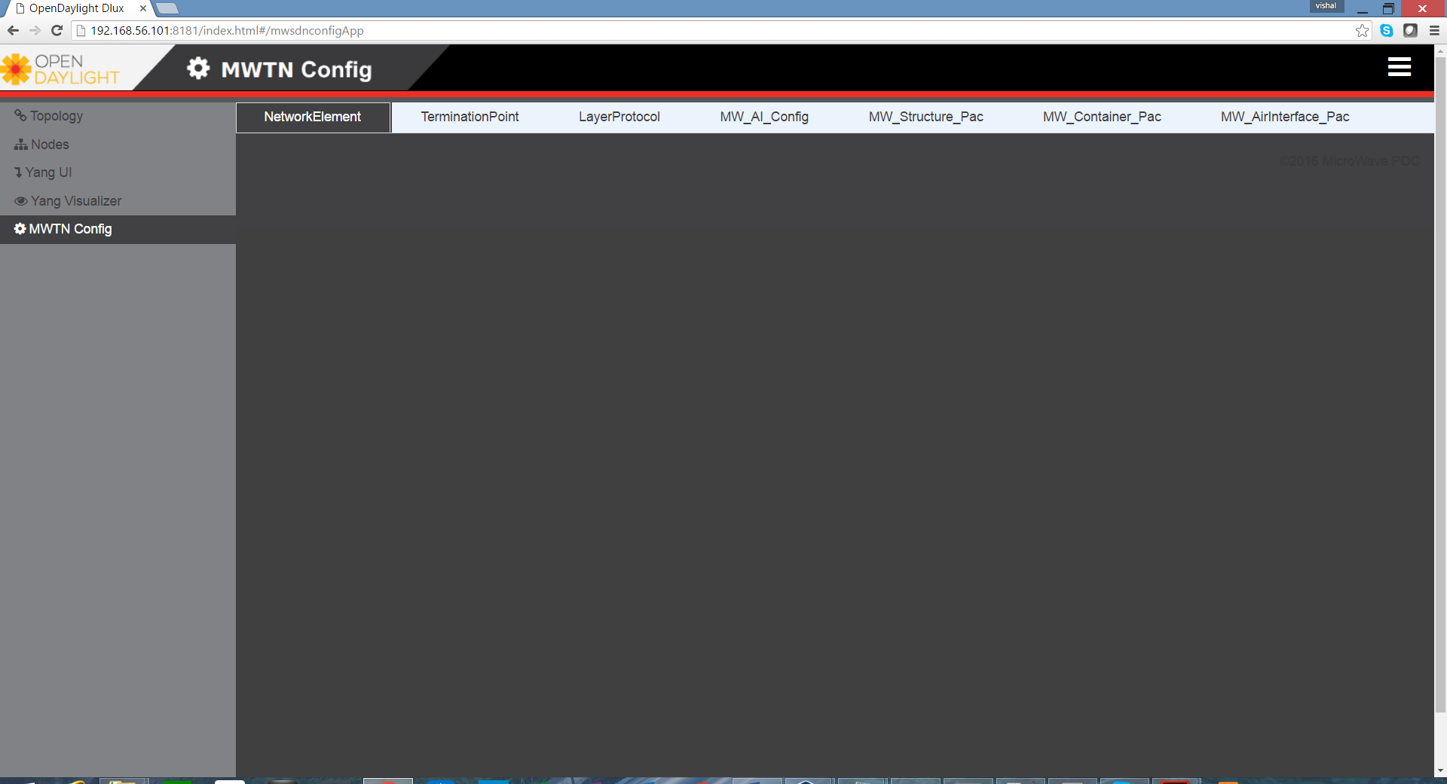

### How it works:

Application is based on REST infrastructure. Application makes a request for the Network element information using the REST calls and shows data in the GUI. For the connection information, first select a NE, then a specific termination point, after that, select one of layer Protocol associated with selected termination point. Application does a REST call for chosen layer protocol and NE and shows the data in GUI.

### How to deploy:

1. Clone this repository
2. Go to the mwsdnconfigApp directory
3. Build the application using the command: mvn clean install.
4. Copy the Application JAR file (./mwsdnconfigApp-bundle/target/mwsdnconfigApp-bundle-1.0.0-SNAPSHOT.jar) into the OpenDaylight karaf deploy directory.

### How to use:

To access the Application, open the ODL DLUX Web UI using the below uri

http://<ODL IP>:<ODL Port/index.html

In the left pane of DLUX GUI a link is available with name “*MWTN Config”.*

Click on “*MWTN Config”.* Link. In the right pane, all the TABS are shown, available with this application.

Click on each TAB to view the respective information.